American History 1492-1876 – BSU History 201 Course

Mr. John Marsh, Associate Lecturer of History Fall 2025
Office: Wagoner 149 E-mail: jsmarsh@bsu.edu
Office Hours: Listed below & by appointment
MWF 10:30-11:30 & 4:00-4:40; Tuesday 10:00-1:00 & 2:00-4:00

OFFICE HOURS AND CONTACTING ME
You can stop by my office anytime to see me. You do not need an appointment. My office is in Wagoner in the hall between the nurses’ office and the tunnel. I will almost always be there during my office hours listed above, and you may find me there at other times as well. If you can’t come during my office hours, we can set an appointment for another time or meet by Zoom. Outside of my office hours, please feel free to email me (jsmarsh@bsu.edu) at any time. Of course, if it is in the evening, you may not get an answer until the next day.

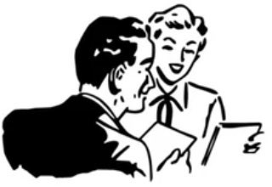
If at any time you have questions, comments, problems, or suggestions please talk to me. If you are having difficulty in the course, don't wait. There are things we can discuss to help you. Most students will find themselves struggling occasionally in some classes, and it’s not a weakness to ask for help. On the contrary, it shows wisdom and determination.

You don’t need to be having a problem to come see me in my office. I encourage you stop in to simply chat. In fact, if you come, sit and talk with me at my office at least once during August & September, I’ll give you 1 extra credit point. That’s a onetime offer, not a point for every visit.

DUAL CREDIT
As you probably know, dual credit means that you can sign up to receive college credits for this course through Ball State. The grade you receive in here will go on your Ball State transcript. The credits, but not the grade, will be transferable to most universities.

If you want dual credit, you must sign up for it. You do not automatically get it just by being in the class. When you sign up, you pay a relatively small fee to Ball State. (It is far less than the regular cost for the credits.) All in all, it is a great way to get a head start on your college career. I encourage you to seriously consider the dual credit option. Please watch for emails from the Guidance Office and your advisor for information on how to sign up.

COURSE DESCRIPTION
This course is a survey of the political, diplomatic, economic, cultural, and sociological forces and adjustments that have affected the history of the United States to 1876. Students will examine key events, ideas, personalities and movements from European exploration to the end of Reconstruction as they relate to life in the United States.

REQUIRED TEXT AND READINGS Abbreviation in schedule
America, Henretta, 3rd Edition (textbook) “America”
Other readings (on Canvas, e-mailed or handed-out) are listed as: “Canvas”

We have the America textbook which we will use occasionally for background information. Most reading assignments will be from short articles, documents, etc., which will be made available electronically. They are listed on the schedule as “Canvas.” It is your responsibility to make sure you have, or can access, the readings for a class. Sometimes, I will list the pages in the America textbook as “For Reference,” which means it is relevant and recommended, but not required.

ASSIGNMENTS
I have listed below the reading assignments for the first month of classes. You must read the assignments PRIOR to the class on the day on which they are listed, and answer any discussion questions I have assigned. I have also included the tentative dates for exams.

 |  | TOPICS | ASSIGNMENTS
Aug | 11 | Introduction | Read Syllabus before class
Aug | 13 | Freedom  Historical Fact/Interpretation  Primary Sources  Assign VA groups | CANVAS: History of Freedom no disc ques  CANVAS: Primary Sources no disc ques  Be ready to discuss these in class
Aug | 15 | Jamestown, Plymouth and Mass. Bay Colonies  You should write at least 1 paragraph on each of the discussion questions from the 2 readings | CANVAS: The Plymouth Experiment DISC QUES:  How did the Pilgrims originally organize their property ownership, what system did they switch to, and how well did that work for them? What do you think are the main reasons for the outcome of the new system?  CANVAS: Metacom’s War DISC QUES: At this time, several tribes of indigenous peoples are attacking farms and villages and making a very bloody war on the Massachusetts Colony. This document contains the actions the legislature orders be taken to stop the war. What things does this document tell us about this colony in 1675?  Remember, your answers must be submitted on Canvas by midnight on the 14th (the night before class)
Aug | 18 | Virginia Colony  Mass. & Virginia compare/contrast | CANVAS: Virginia Colony DISC QUES: The pages you read depend on which topic you were assigned  Economics & Geography of the VA Colony: pages 105-110 & 116-123  Government/Politics of the VA Colony: pages 110-123  Religion in the VA Colony: pages 123-139  Make a bullet list from the reading of all the significant points regarding your topic and post it on Canvas. It would typically be around 10-15 items. In class, you will be combining your list with that of others who were assigned that same topic, and writing it on the board to share with the class.
Aug | 20 | New Netherlands  Pennsylvania | Map Quiz  CANVAS: Selections from The Island at the Center of the World – no discussion questions  CANVAS: Watch 5 minute video: Forgotten Founding Father Adriaan van der Donck – no discussion questions  CANVAS: A Description of Philadelphia – no discussion questions
Aug | 22 | Social/Economic aspects of the colonies | CANVAS: Poor Richards Almanac Selections – no disc ques  CANVAS: The Nature and Necessity of a Paper Currency DISC QUES Remember, if I don’t list the discussion questions here in the schedule, you’ll find them at the start of the document  CANVAS: Boston Massacre Trial introduction and documents. We will discuss in class and meet in groups at the end of the period
Aug | 25 | Colonial Wars  Causes of the American Revolution | CANVAS: Geo Washington letter on Braddock’s defeat – no disc ques  AMERICA: 119-122 – no disc ques
Aug | 27 | Stamp Act  Causes of the American Revolution | CANVAS: Resolutions of the Stamp Act Congress DISC QUES
Aug | 29 | BOSTON MASSACRE TRIAL | Prep for the trial with the documents and your partners.  Academy staff and parents/guests will be the jury
Sept | 3 | Debrief Trial  Causes of the American Revolution | CANVAS: Boston Massacre Images and Perspectives  This assignment will only take you about 5 minutes. You don’t have to read much or write anything. You just look at a few images and a quote and think about some questions I ask. We’ll discuss the items in class.
Sept | 5 | EXAM 1
Sept | 8 | Causes of the American Revolution | CANVAS: Common Sense DISC QUES
Sept | 10 | Early American Revolution | CANVAS: Declaration of Independence DISC QUES

It is not necessary for you to bring the America textbook to class unless I instruct you to ahead of time. However, you are required to bring to class any reading from Canvas which was assigned for that day. We usually use the text of the readings in our discussions, so you must have a copy to which you can refer. You can either bring it on your laptop, or print out the reading and bring it. Not having the assigned readings in class will negatively impact your class participation grade.

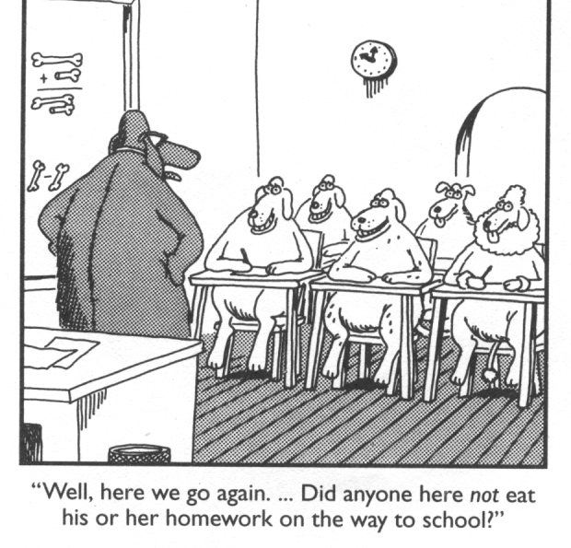
As the course progresses, it may be necessary to modify some assignments. I will give you notice of a week or more on changes to exams or major assignments. I will generally give you notice of several days or more if I change a reading assignment. However, circumstances occasionally require minor last minute changes or additions. I will e-mail to you any such changes no later than 6:00pm on the day before class. So, you are responsible for checking your e-mail after 6:00pm on the night before class.

TENTATIVE EXAM DATES
Sept 5 Exam 1
Late Sept Exam 2
Late Oct Exam 3
Early Dec Exam 4
Dec 15-18 Final Exam TBA

CLASS POLICIES

INDIANA ACADEMY ATTENDENCE POLICY
Attendance is mandatory. Students may receive excused absences at the professional discretion of the school nurse, the associate director of mental health services, the associate director of college counseling and student engagement, the director of academic affairs, and the executive director of the Indiana Academy. Unexcused absences occur when students miss class without prior approval from the aforementioned designated school officials. Continued absences (both excused and unexcused) from Academy classes increase the likelihood of unsuccessful completion.

Alongside steady attendance, students are expected to maintain consistent healthy habits of decorum, respect, and kindness towards their classmates, instructors, and teaching assistants. When students fail to meet these classroom behavioral standards and academic habits, it is the expectation faculty engage appropriately to bring quick and immediate resolution. When students consistently fail to meet these behavioral standards and academic habits in the classroom, an administrative consequence ladder will be adopted, and recorded,
in attempt to administratively address, engage, and rectify ongoing challenges.

ATTENDANCE AND TARDIES: The policies in the Student Handbook regarding attendance and tardiness will be followed in this class. Students are expected to attend, and be on time, for every class. If you are not in the classroom by the official starting time, you will be marked tardy. If you arrive more than 15 minutes late, you will be marked absent, however you will still be able to turn in assignments, per late policy listed below, and participate in the educational activities of the day, so it is definitely in your best interest to attend. You must notify me in advance, using Academy procedures, in the case of pre-arranged absences. Academy policy allows a faculty member to report a student as having an unexcused absence for sleeping in class or for improper use of their computer, tablet or phone during class.

MAKEUP WORK FOR EXCUSED ABSENCES: Exams, quizzes, online discussions and other assignments missed must be made up within 1 week from the date of your return, unless other arrangements are made with me in advance. Additional time can be granted for extenuating circumstances such as extended illnesses, but you must communicate with me in a timely fashion. Do not wait for me to contact you regarding a makeup. It is your responsibility to contact me to schedule a makeup exam. Likewise, for homework and class material, it is your responsibility to find out what you missed and how to make it up.

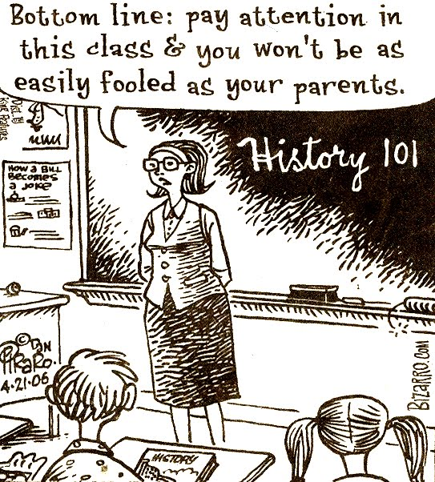
INDIANA ACADEMY UNEXCUSED ABSENCE POLICY
It is the policy of the Indiana Academy that any absence from class is unexcused, except for illness, death in the family, college or school-related activities, and extenuating circumstances. When a student is absent from a class, the instructor reports the student absence to the Faculty Attendance Coordinator in the Office of Academic Affairs. Unless the absence is excused by a school official, it is considered unexcused. The decision as to whether an absence is excused is not determined by the instructor. Although all absences, both excused and unexcused, are tracked within the Office of Academic Affairs, professors of each class are free to use discretion with a student’s first three unexcused absences. Four or more unexcused absences in any particular class a student takes will lead to academic and residential consequences to be determined by the Office of Academic Affairs and the Office of Residential Life that may include detention, residential groundings, parent/principal conference, among others.

CONSEQUENCES IN THIS CLASS FOR UNEXCUSED ABSENCES: There is no right to make up quizzes, discussion questions and other similar assignments as a result of an unexcused absence. However, you should still talk with me about how to not fall behind with the course material as a result of the unexcused absence. You will be given an opportunity to take an exam you missed due to an unexcused absence, but there will be a 1-letter-grade penalty on that exam score. That exam must be made up before I hand them back in class (usually about a week). After that, a zero will be entered for the exam score.
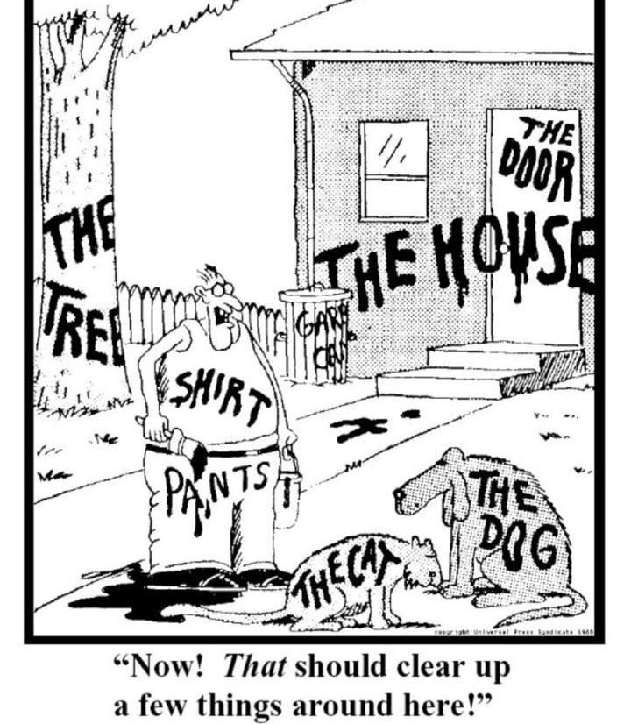
Unexcused absences will also negatively impact your Class Participation grade. You are allowed 2 unexcused absences without penalty to your Class Participation grade. 3 points will be deducted from your Class Participation grade for every unexcused absence after that.

Please be aware that Academy policy allows a faculty member to report a student as having an unexcused absence for sleeping in class or improper computer use in class.

ACADEMIC DISHONESTY: Academic dishonesty (cheating) will not be tolerated. Some examples of academic dishonesty include, but are not limited to: copying or facilitating copying during exams, turning in written assignments with the same language as others, and copying from internet or print sources without proper citation. Cases of academic dishonesty will be dealt with according to the policies in the Student Handbook. If you have any questions on what constitutes academic dishonesty, I strongly encourage you to consult the Student Handbook, or discuss it with me. Academic Integrity policies are found here in the online student handbook: https://academy.bsu.edu/handbook/academic-integrity/

HUMANITIES DIVISION STATEMENT ON AI
The Humanities Division recognizes that artificial intelligence (AI) provides some exciting new tools for academic work. However, AI also poses significant dangers for academic integrity. Passing off as your own any research, words, or ideas which you did not create is plagiarism. That is always the case whether the source is print, internet content, or generated by AI. It is vital to read the policies your individual humanities instructors have regarding AI, and ask them any questions you may have about the use of AI in their course.

USE OF AI IN THIS COURSE
AI will be a very useful tool to you throughout your life, but don’t let it do your thinking for you. That’s a recipe for personal and societal decline. Use of AI when you are reading the assignments and prepping your answers to the discussion questions will significantly reduce the educational benefit to you, because the main goal is to continue to build your critical thinking skills. Furthermore, you’ll have to explain these topics on the exams, so you’ll need to be able to think through them before then anyway. Best to spread out your study of these topics and not try to cram them all in the night before the exam.

So now that you know the rationale, here are the policies for regarding AI in this course. You can NOT use AI for Discussion Question assignments. Using any wording or even paraphrased wording you got from an AI program in your answers is considered academic dishonesty (cheating) in this course, and it will be tracked and enforced using the Academy’s policies on academic dishonesty. Using AI to create your answers is passing off some computer’s ideas as your own.

You also can NOT use AI in the classroom unless I specifically say it is ok for a particular activity. Remember, I can look at your computer at any time while you are in class. Use of AI in class, whether for a discussion, quiz or other activity will result in a charge of Academic dishonesty. Don’t even have the program up on your computer. For example, if we are having a discussion in class where you are asked to analyze something, and you quickly ask an AI program to do that, and then you give that as your analysis, again, you would be passing off some computer’s thoughts as your own.

You must include this affirmation at the end of EVERY discussion question assignment: “I affirm that I read the assigned texts and created the answers myself. I did not use AI in any way on this assignment.”

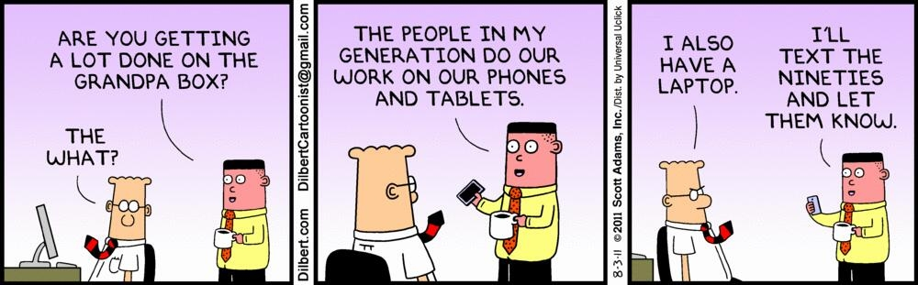
When can I use AI in this class? You can use AI for studying for exams and research NOT related to the discussion questions. There may be some assignments on which I specifically encourage you to use AI, and I will of course inform you of those when the time comes.

LAPTOPS: You may use your laptop in class to take notes. Remember, you are required to have in class the text of any reading assignment which was given out in electronic format (i.e. e-mailed to you or posted on Canvas). So you must either bring your laptop that day or a printout of the readings. Otherwise, you are not required to bring your laptop to class unless I tell you in advance. You cannot use your cell phone to access the readings unless I approve it in advance.

Surfing the web, e-mailing, Instagram or any other activities are strictly forbidden during class. Using your laptop for anything other than educational purposes connected to the class will result in an unexcused absence for that class period, plus 5 points will automatically be subtracted from your participation grade.

A second infraction will result in another unexcused absence, 5 more lost points, and you will be banned from bringing your laptop to class. I reserve the right to check your screen and currently running programs at any time during the class. Use of your laptop in class is a privilege, not a right.

I will periodically check computers to verify that only notetaking programs are in use. Quickly trying to hide other programs, or lying to an instructor about improper computer use is considered a violation of Academy academic dishonesty policy and will be dealt with accordingly.

CLASS ATMOSPHERE: Feel free to ask questions during the lectures, but always raise your hand and be recognized. Sometimes, if I am in the middle of making a point, I may signal that I have seen you, and will go ahead and complete my point before getting to your question. During class discussions as well, please raise your hand before speaking. Just as in the professional world, an atmosphere of mutual respect and appropriate behavior will be expected at all times. That includes listening to your fellow students as respectfully as you would to me. In addition, it is important to remember that topics we explore during class discussions will be on the exams as well. So don’t relax your concentration on the material just because I’m not lecturing.

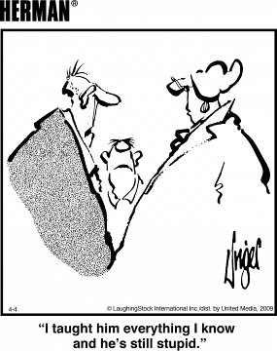
Democracy is by definition, conversation. Ideas, perspectives and information are exchanged in the political decision-making process. Consequently, the right to freedom of speech, and the ability to have civil discourse in the public sphere are essential to a functioning democratic system. Anyone paying attention in recent years has noticed that our body politic has become increasingly polarized, and reasoned debate has often been supplanted by bitter personal attacks. Impugning the character and motives of someone is a way to marginalize and silence them. Many attempt to delegitimize their opponents with labels, so that they do not have to debate the substance of their ideas or policy suggestions.

This class is not a current events debate club. Our focus is not on arguing personal political views, and no one will ever be put on the spot for their personal opinions. However, we will be analyzing and discussing historical issues, events, ideas and policies, and connecting them, where applicable, to current issues. Historical information and analysis are vital to the educated citizen in making informed decisions in our system of self-government.

So despite what is going on in the broader political sphere, in this classroom we will be practicing respectful and productive civil discourse. Politely disagreeing with the substance of ideas, and offering reasoned alternatives is always permissible, and is in fact healthy in a democratic system. But attacking another’s character or motivations for their views, or referencing their personal characteristics or appearance, will not be allowed. This policy includes any online discussions we may have as part of this class. It also extends outside the classroom as well. Making derogatory comments about another student based on their expressed or assumed views as a result of a class discussion will not be tolerated. Should any such behavior also be in violation of Academy policies, such as those regarding bullying, Academy disciplinary procedures will be followed.

So our class will be a model of civil discourse, and who knows, maybe our civility will rub off on others in our society.

INDIANA ACADEMY WIRELESS DEVICE POLICY
Pursuant to Indiana Code 20-26-5-40.7, The Indiana Academy for Science, Mathematics and Humanities prohibits student use of wireless communication devices for non-instructional purposes in the classroom. As such, any and all portable wireless devices, that have the capability to provide voice, messaging, or other data communication between two or more parties, must only be used for academic purposes directly tied to the classroom activity or related educational task. Exceptions to this wireless device policy are eligible through academic accommodations, individualized education programs, or with instructor approval permitting the use of a wireless device for justification related to health, safety, and/or well-being.

The improper use of a wireless device in an active classroom setting is subject
to disciplinary action including but not limited to; a verbal warning, temporary
seizure of said device by a school official, an unexcused absence for the class
in question, written communication to parent/guardian, among other elevated
consequences for repeated improper use.

HISTORY DEPARTMENT CONTENT WARNING STATEMENT
As with many history classes, the lectures, readings, and discussions will include a range of topics that may be triggering, emotionally distressing, and difficult for some students. Engaging with topics such as slavery and human suffering is essential to this discipline. History seeks to understand the experiences and thought processes of former generations, whether for good or ill. Sometimes the language and word choices used by people in the past may be insensitive or politically incorrect today. Nevertheless, the goal of history is to understand the past within its own context and time. If a reading, image shown in class, or discussion is truly troubling to anyone, please do not hesitate to talk to your instructor. In some circumstances, an alternative reading can be assigned.

BALL STATE UNIVERSITY DIVERSITY POLICY
Ball State University aspires to be a university that attracts and retains outstanding faculty, staff, and students. Ball State is committed to ensuring that all members of the campus community are welcome through our practice of valuing the varied experiences and worldviews of the people whom we serve. We promote a culture of respect and civil discourse as evident in our Beneficence Pledge. As a reflection of Ball State’s commitment to respect, civil discourse, and the Beneficence Pledge, inclusiveness at the Indiana Academy emerges as one of the priorities of our living and learning community. We strive to exist together respectfully and compassionately, creating an environment where every member can thrive.

MY ADDITIONAL COMMENTS: I am personally committed to doing everything I can to see that every student has the best possible experience in my course. So if I make a mistake on a name or a pronoun, please correct me. If there is something that is said in class, by me or another student, which bothers you or gives you concern, please talk to me. In our course, as in society at large, we can best address our problems and concerns with open communication.

GRADING
Grading in the course will be based on the following:
Quizzes 20-30 points
Discussion Questions 80-100 points
Class participation Q1 50 points
Class participation Q2 50 points
Exam 1 50 points
Exam 2 50 points
Exam 3 50 points
Exam 4 50 points
Final Comprehensive Exam 100 points

Final grades will be assigned according to the following scale:
A = 92-100% B+ = 88-89% B- = 80-81% C = 72-77% D* = <70%
- = 90-91% B = 82-87% C+ = 78-79% C- = 70-71%

EXAMS & QUIZZES

The exams will be composed of both objective and essay questions. Exams 1-4 will be over the current material. The Final Exam will be drawn from the first 4 exams. So keep the exams to study for the Final Exam. I will provide some sample questions prior to the first exam.

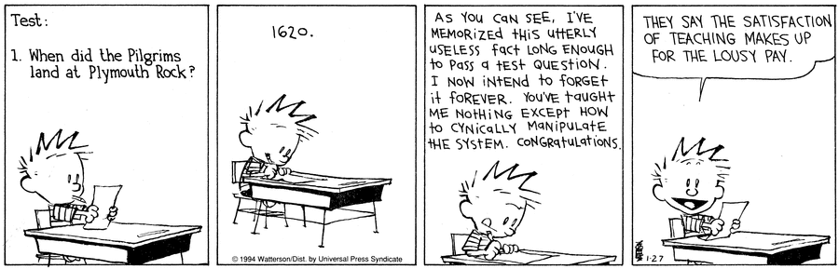
Exams 1-4 are worth 50 points each. I will drop your lowest of those 4 exams, as long as that helps your final course grade. This way, if you had particular trouble on one exam, it won’t negatively impact your final grade. Occasionally, a student performs extremely well on all the exams in comparison to other grades in the course, and dropping the lowest exam would actually lower their grade. In that case, the exam is not dropped. The Final Exam is not dropped, except in the rare case of substantial extenuating circumstances, such as an extended illness.

Although I don’t plan to use them, I reserve the right to give pop quizzes at any time, for any reason. There will be no make ups for pop quizzes. If you have an excused absence, that quiz will not be used in calculating your grade. If you have an unexcused absence, you will receive a zero for the quiz.

CLASS PARTICIPATION
Learning is an active process, and the more you are engaged, the more you will get out of this course. I reserve 100 points during the semester for a participation grade. The participation grade is based on my assessment of your performance in the following areas:
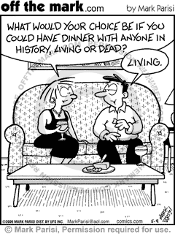
- Attentiveness during lectures
- Studying assignments prior to class, taking notes on readings, answering discussion questions and bringing the necessary readings to class
- Participation in class discussions, simulations, and activities
- Participation and effort in group projects
- Adherence to the standards of classroom conduct

During the course of our class discussions it will become obvious who has prepared and who has not. I usually do not call on students who do not have their hands up and ask them to answer a new question in class. However, if it is a discussion question I provided before the class, I will assume everybody is ready to go with an answer. I often will call on students at random for those. Students who do not read the assignments and do not prepare responses to discussion questions will lose points on their class participation scores, and will have more trouble on exams.

I know that for some of you, speaking in class is not your favorite thing, and that’s okay. However, as a professional, you are going to need to speak in meetings, small groups and even large groups. So you need to continue to enhance those skills and be ready, and this is a good safe place to do that. It is not a contest, and I am not scoring who talks the most in each class period. So I don’t want you to feel it is a disaster to your participation grade if you didn’t raise your hand in class on a particular day. However, you do have to get your hand up and voluntarily join the conversation at least some of the times. If you never raise your hand in class to get in the discussions, the best you will be able to get on class participation is a C.

Remember, improper use of your laptop during class will cost you 5 points for each infraction. To put that in perspective, losing 5 points is equivalent to dropping an entire letter grade on one of the 50 point exams. Don’t risk it.

I will post 50 points of your participation grade at the end of the first quarter, and the other 50 points at the end of the semester. If you have any questions regarding your standing in that category at any point during the semester, please talk to me.

DISCUSSION QUESTIONS (DISC QUES)
Discussion Question Requirements Summary:
- Must be submitted on Canvas by midnight on the night before class
- Must be good academic writing in sentence and paragraph form
- Focused on your own personal analysis of the issues, and based on the facts
- You cannot use AI in their creation
- Paste in the box, do NOT attach files
- Paste in the Affirmation you did not use AI

In this class, you will be doing much of the work of the historian. That is, instead of only reading textbooks that have all the material boiled down for you, you will often be working with the same kinds of primary source documents that historians study. Primary sources are created during, or near, the time period being studied and include things such as letters, bills, legal acts, diaries, speeches, interviews, business transactions, and proclamations, as well as artifacts other than documents. They are the “original,” first-hand sources of history that are studied and used to create secondary sources, such as textbooks. One of the readings for the second day of class will explain primary sources further.

A central feature of this class will be our study, analysis, and discussion of these primary sources as we seek to understand the key historical issues. Therefore, it is absolutely essential that you prepare for every class by reading and studying the assignments for that day. If students have not read the material, then we cannot have productive discussions.

To that end, we will have discussion questions assigned for most primary source readings, as well as a few secondary source readings. Details and requirements of discussion questions are as follows:
- They will normally be worth a total of 4 points for each class for which they are assigned. Overall, they will total around 80-100 points for the semester. That is as much as 2 exams.
- When you open the assignment on Canvas, you will find a submission box. That is where you post your answers. I strongly suggest you write your answers in a word processing program first, then paste them in the box. That is because sometimes computers can freeze or crash, and programs can time out. If those things happen, you will lose what you have written.
- Do NOT attach files. Paste your answers directly in the submission box. If you attach a file, I won’t read it.
- You must post your answers by midnight the night before class. That gives me a chance to look at your answers before class.
- If they are not posted by midnight the night before class, you have one week to submit them for half credit. After that, they will not be accepted and a zero will go in the gradebook, unless I make exceptions for extenuating circumstances.
- Your answers must be in sentence and paragraph form. No sentence fragments or entirely bullet listed entries. (You may occasionally include a bullet list within the writing if it seems to be a good way to convey particular information.) Be sure to use proper grammar and spelling. In other words, I want you to practice good, clear academic writing. That will be part of the criteria I use in grading the discussion questions.
- Since you are writing about your thoughts and analysis of the readings, you can use “I,” as in, “I think such and such.” In fact, you will probably use that perspective often.
- Back up your points with specific examples from the readings. That is a key part of your grade. Giving your opinions is good, but you need to support them.
- Put your name, the date assigned and the title of the reading(s) at the top of your assignment.
- The total length of all your answers for a given day should be around 2-4 paragraphs, depending on how long and how detailed the reading(s) are, and how many discussion questions there are. Some questions can be answered in a sentence or two. Others will require longer answers.
- I will designate all readings that require discussion questions with “DISC QUES” in the assignment schedule. Sometimes I will list the questions right there in the schedule. Other times the questions will be listed at the start of the reading. Any readings that do not have the DISC QUES designation do not require discussion questions. Usually only about two thirds of the readings will have discussion questions. That does not mean that the other readings are not important. They are important to your overall understanding of the topics, and I will expect you to have read them before class as well.
- You cannot use AI in the creation of your answers. Using wording from AI, or even paraphrasing wording from AI is considered Academic Dishonesty in this course, and will be dealt with according to Academy policy.
- You must include this affirmation at the end of EVERY discussion question assignment: “I affirm that I read the assigned texts and created the answers myself. I did not use AI in any way on this assignment.”

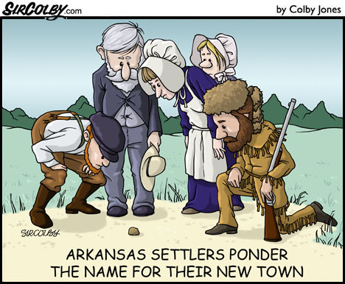
There are multiple purposes for the discussion questions. One is to help you focus your thoughts on what you have read so that you are ready to discuss the material. The idea is that you are not just scanning the material, but thinking about it and analyzing it. The readings are usually fairly short, so you should have ample time to digest them. Obviously, along with that, the discussion questions let me know that you have done the reading for each class.

During class, be sure to have your answers in front of you so you can refer to them, either on your computer/tablet or printed out. Having answers in front of you will hopefully reduce any anxiety you might have about participating in class discussions.

A second purpose is to provide you with notes on the readings which you can use for studying for the exam. Reviewing the discussion questions and your class notes on the associated discussion should prepare you well for questions on the exam regarding the readings.

A third purpose is to help boost your grade. The discussion questions are a matter of effort. Anyone can earn all the points possible by simply putting in the time and thought. So if you don’t perform as high as you’d like on the exams, the discussion questions can bring your
grade up.

Keep in mind, this is not busy-work regurgitation. I do not want just some generalized summary of what was said in the reading. I know what is in the reading. I am looking for evidence that you have thought about and analyzed the concepts in the reading(s).
Also, this is not math class where there is only one set of “right” answers. Students may end up focusing on different aspects of a reading, so their comments may be very different from one another. As long as their underlying facts are correct, and they demonstrate sound thinking and analysis, those different sounding answers can all earn full credit.

On some days, or on some readings, I will not ask specific questions. The onus will be on you to determine the main ideas of the reading(s). I will list those readings in the schedule as “Your Own Analysis.” On those occasions, here are some basic questions you can keep in mind which you may want to answer:
- Who wrote this and what was their purpose?
- What are their biases?
- What is/are the central idea(s) or main point(s)?
- What else can you learn from it?
- What connections can you make to what we have studied so far?
- What is your reaction or opinion about it?
- What questions do you have about it?

The above questions are just a general framework, but you often do not need to say something on every one of them. Some will be too obvious or basic for a particular reading. For example, you don’t need to say “Lincoln’s Second Inaugural Address was written by Lincoln to give at his second inauguration.” Also, some of the questions may not be relevant to a particular reading. So although you will likely address at least some of the above questions (particularly the one in bold), I do not want simply a brief listing of answers to all those questions. I am more interested in your answers to a couple of them into which you have clearly put some thought.

That brings us back to the central idea, which is that the main thing I will be looking for in your answers is evidence that you read and thought about the assignments. I can clearly tell the difference between someone who has read and analyzed the material, and someone who just scanned it for the answers, or perused the headings.
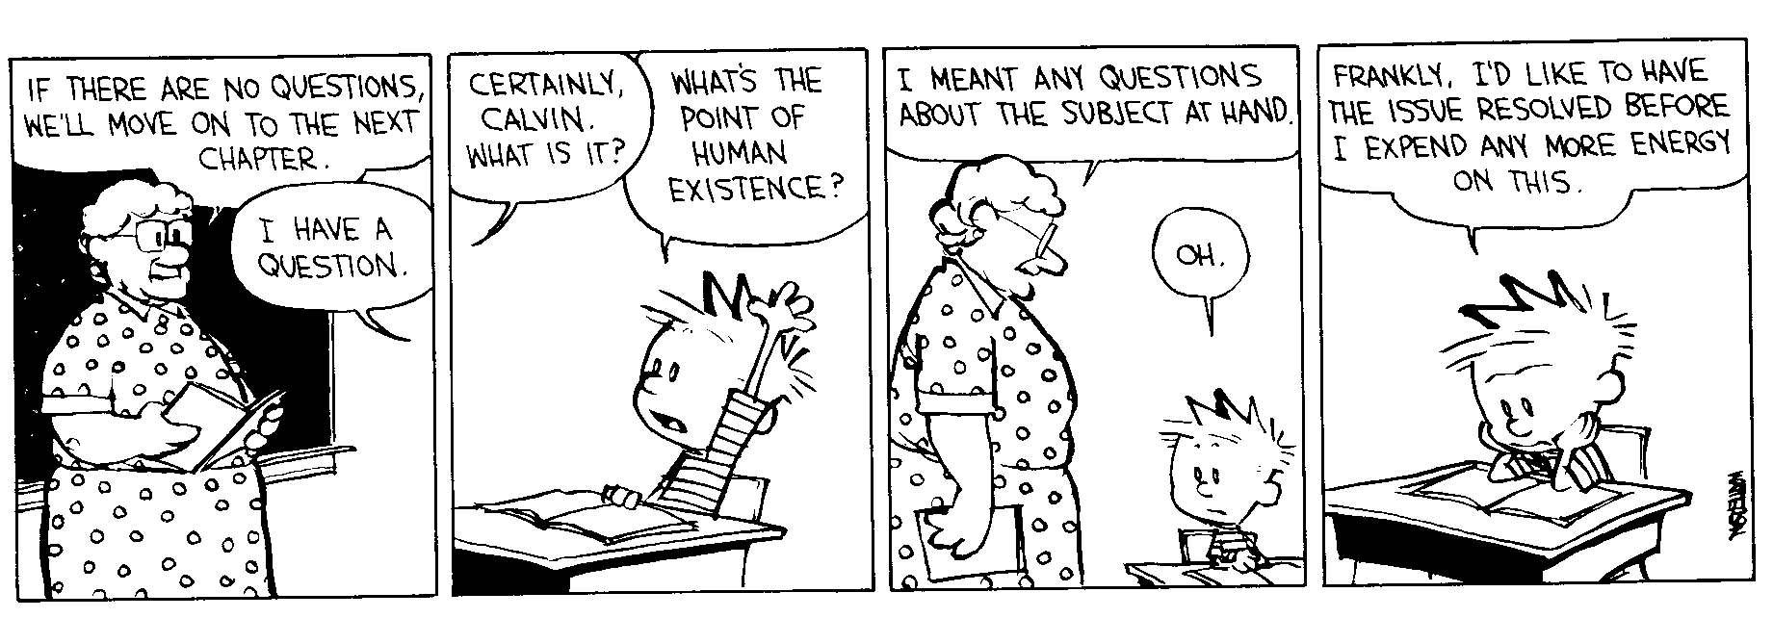
I suggest you read the discussion questions first to have them in mind. Then read the assignments and take a few notes on them. Then write up your answers/analysis.

Remember, Discussion Questions are due by midnight on the night before they are listed in the schedule. If you fail to post them by that time, you will have one week to turn them in for half credit. After that, no credit will be given unless I determine there are some extenuating circumstances.

I will give you one free pass. That is, I will drop one discussion question assignment that you miss, or the lowest one on which you get a score less than your course average. In the vast majority of cases that means a score less than a 4.

My grading on Discussion Questions will be as follows:
- 4 points – on time, accurate, evidence of thought and analysis, specific examples, good academic writing quality
- 3 points – on time, generally acceptable but some weaknesses in accuracy, presentation, and/or analysis
- 2 points – on time, but poorly done; OR late but otherwise well done
- 1 point – late, generally acceptable but some weaknesses in accuracy, presentation and/or analysis
If I take off points when grading, I will post some brief comments as to why. As always, if you have any questions on the grading or my comments, please ask me.

Remember, any use of AI in the creation of your answers will be considered Academic Dishonesty (cheating) and will be handled in accordance with Academy policy. As part of my policing of this policy, students may be asked to explain the readings and their answers to me in oral or written form without the use of their submitted answers.

Again, like all the grades in this class, if you have any questions regarding your performance, please talk to me.

SAMPLE DISCUSSION QUESTION ANSWERS
Here are some sample student answers from a reading I have used in this class in the past. It is a primary source document which includes instructions from the directors of the Virginia Company to the leaders of the party they have sent to start Jamestown colony in the New World.

Sample 1
This document was written in 1606 and gives instructions from the Virginia Company to its settlers in Jamestown, which was the first successful English colony in America. It gives a lot of detail on a wide range of issues. For example, it gives extensive instructions on how to select a site for the colony such as how to choose a river, how far up it to sail, and where to locate the fort. It sounded like they thought the fort was most needed for protecting against the Spanish and the French.

The instructions get oddly specific in some places. When talking about how the colonists should look for minerals, they say, “When they do espie any high lands or hills, Captain Gosnold may take twenty of the company to cross over the lands, and carrying half a dozen pickaxes to try if they can find any minerals.” How company officials sitting in offices across the Atlantic Ocean should know exactly how many men and pickaxes should be used in a hypothetical situation seems very strange to me.

I was also surprised about how the instructions mentioned more than once that the settlers should “have great care not to offend the naturals,” and to treat them with kindness. We were generally taught that the English colonists didn’t care about the Native Americans. It also said the settlers should choose land which was not already inhabited by the natives. I can see a potential problem with those instructions though, because there may be a reason why land is uninhabited by the natives. Perhaps it is swampy or has bad water.

Sample 2
These were a bunch of instructions on how to start a clonoy. They told the men to look for gold, and also to sail up the rivers to look for India. This was when America was just getting started. Captain newport is in charge so he is mentioned several times. Other things they said was to not plant in certain kinds of places. they also said they should not let the natives know if there people got sick and died. I thought the reading was very interesting. It just goes to show how hard it is to start a colony.

Analysis
Which student do you think put some time into studying the reading and thinking about it? Which student do you think will be better prepared to participate in the class discussion, or to answer questions about the reading on an exam? It’s not too tough to tell, is it?

Look at sample two. The writing is vague and, in some places, lacks specific examples from the text. It is also rambling, disorganized, too brief and all in one paragraph. There are misspellings, problems with verb tense, capitalization and word choice. It is also just listing things from the text, but not really analyzing them. It scored a 2 out of 4.

Contrast that with sample one. It is well written and the points the student makes are backed by examples, and sometimes quotations from the text. Remember the main thing I said I wanted to see was evidence that the student had thought about what they read. This student had observations on the Spanish and French being the biggest danger, how specific the instructions were, the points made about indigenous peoples, and a potential problem they saw in the instruction about choosing land. This scored a 4 out of 4.

Tips on Doing Well in the Course

TAKING NOTES
- Read the assigned sections in the text before class. Even if you don’t fully grasp it all the first time through, it will provide helpful context for the lecture.
- During lecture, focus on the main points. You can’t possibly write down every word I say, but you can write down phrases, names, examples, concepts, and basic elements of a story.
- Be sure to write down any lists, summations, and conclusions I make, as well as anything I repeat.
- If you didn’t hear or understand something, you may raise your hand and ask me. Otherwise, skip it and talk to me or a fellow student after class. Do NOT ask your neighbor during lecture as you will miss the current comments and fall farther behind. In addition, it will distract those around you.
- Read your notes as soon as you can after class, and make additions, corrections, or organizational changes while the lecture is still fresh in your mind. Also, if you are unclear on any material, you can ask me about it. This way you will have thorough notes, which you have already reviewed once, when it’s time to study for an exam. On the other hand, if you wait until the night before the exam to read your notes, some points will seem unclear, and any gaps will be harder to fill in.
- Review the PowerPoints posted on Canvas and compare them with your notes. However, please note that the PowerPoints are mostly images. They are not a substitute for your notes!
- You may record the lectures if you wish.
- Make sure your note-taking system is organized. If you have to hunt all over your computer to match up notes from 2 successive days of class, then you need a better system.
- Remember, paying close attention and taking good notes during lecture is the first big step in studying for the exams.

EXAM PREPARATION

NOTES: Your notes are your best source of information for the exams. I am most likely to ask questions in a way that matches the description I gave in class. Study them thoroughly. I would suggest starting your studying with your notes in conjunction with the PowerPoints.

POWERPOINTS: I post the PowerPoints I use in class on Canvas before the exams. I suggest you open them up and use them to follow along with and reinforce your notes. Please note that the PowerPoints are mostly images. They are not a substitute for your notes!

READINGS: The readings contain many of the essential concepts we will be studying in class. As mentioned above, you will be able to follow the lectures more easily if you have read the assignments ahead of time.

Be careful not to let the amount of information in the text overwhelm you. In the first place, when studying the text, continually try to focus in on the key ideas. Ask yourself what are the main points, trends, events, ideas, etc. that the authors are trying to get across to you in each section. Second, use your study guides as described below.

STUDY GUIDES: The study guides list the specific names and terms which you will need to know for each exam. Most of the study terms will be covered in lecture. There may be a few that are not covered in lecture, and it is your responsibility to get their definitions from the textbook. Use the index if necessary.

Regarding the textbook, any names or terms that are neither covered in lecture nor listed on the study terms will not be on the exams. For example, if the textbook talks about a King Buford the Unhinged, but he’s not on the study terms, and I don’t mention him in lecture, then he will not be on an exam.
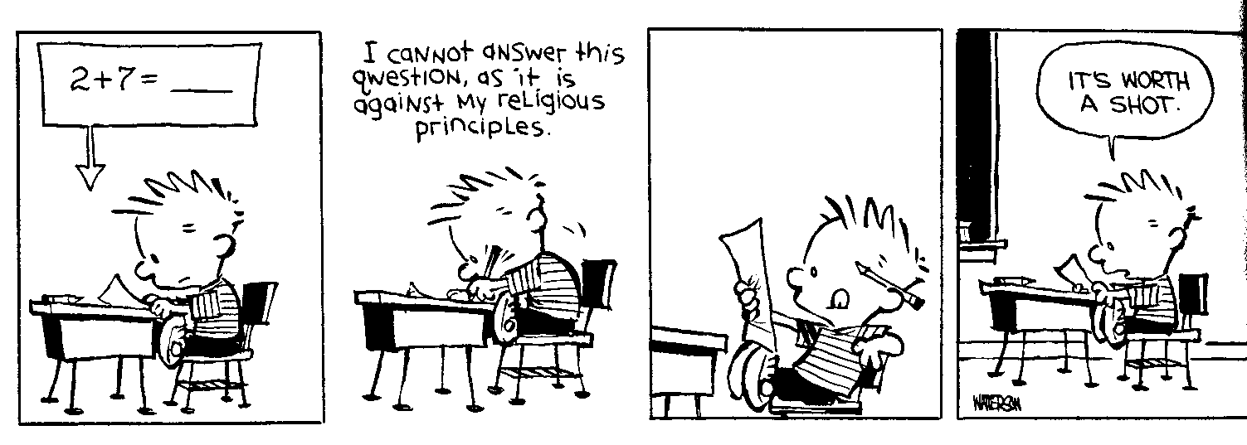
The terms on the study guides will sometimes coincide with the order they are discussed in lecture. However, the guides are not lecture outlines, and I strongly recommend that you take notes on separate paper, and do not try to follow along on the study guides during class. After class, you should use information from your notes to define the names and terms on the study guides.

It is very important to keep in mind that the study guides address specific names and terms. They do NOT contain all the concepts and information covered in lecture. In other words, the study guides are to supplement your notes; they are not a substitute for them.

This paragraph has nothing to do with study guides. I just wanted to bury a little note in here. Congratulations for showing the motivation and good sense to have read through the syllabus. You already possess the key ingredients to doing just fine in this course. You would be surprised at how many of your classmates did not read this far. So, as a little token of recognition of your starting effort, send me an email, before the start of our second class (Aug 13) with your name on it and these exact words, “I can’t wait to learn some history!” That will earn you 1 point of extra credit. It’s our little secret, so don’t mention it to any of your fellow students before class, or I won’t give you your point.

CHRONOLOGY & DATES: You will be required to know the basic chronological order of the major topics. For example, you’ll need to know that the French and Indian War came prior to the Revolution, and that fighting during the Revolution started more than a year before the Declaration of Independence was signed. As for specific dates, before each exam, I will give you a list of 5 or so significant dates which you must memorize. Those are the only dates which you will have to list on the exam.

PUT YOURSELF IN A TEST SITUATION: Some students just read over the notes, terms, and dates a few times, and after they think they’ve put in enough time, they quit. Then when faced with having to recall information on the exam, they “draw a blank.” To perform your best, you really need to spend at least some of your study time making yourself recall the material. For example, cover up the definitions of the study terms, make flash cards, or have a friend quiz you. If you have practiced putting yourself in a test situation, then during the exam, you will find yourself more able to recall the required information.

A word of caution about Quizlets is needed here. The concept of them is good. It is putting yourself in a test situation, which as I said, should be most helpful to you. The problem is that the Quizlet is only as good as the information put into it. I have no problem with you using a Quizlet which another student made up and shared with you. But if it is missing a number of key points and terms, and/or has a number of items on it which you do not need, then you could be seriously wasting your time.

SEEK HELP IF YOU NEED IT: It will be most productive if you study the material first, and then if you generate any questions, or want to see if you are on the right track with your essay answers, please contact me or see me. I’m happy to help you. You may also find it helpful to review material with other students. I have 2 sections of this class, so there will be 30-40 students preparing for the same exam.

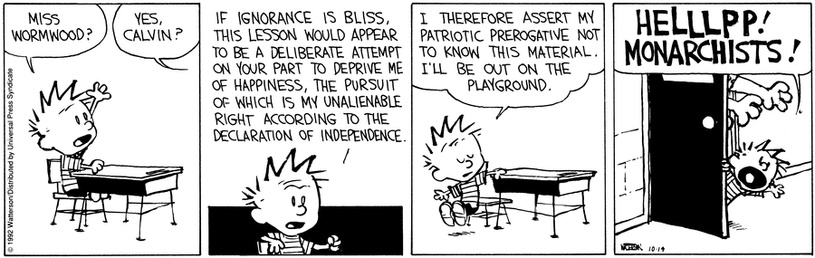

BSU Course Overview
You can skip this last section. The following information is from the general description the Ball State History Department uses for this dual credit course. It is included here for your information, but is not as critical to your understanding of this course as my preceding information.

COURSE METHODOLOGY
This course will use a variety of active-learning strategies that include modified lectures, in-class exercises revolving around the use of primary and secondary source materials, and writing assignments. These pedagogies will help students explain:
- the difference between a primary and secondary source
- historical methodology—how historians use primary and secondary sources to establish historical facts and interpretations of historical events
- historical thinking—how theories and context influence the ways historians think about historical episodes and construct their interpretations
- the existence and interaction of the different fields of history—political, diplomatic, economic, social, and cultural history
- the different approaches taken by historians as they reflect upon the experiences of the past

Students will develop the following cognitive skills:
- accurately observe (read) and reconstruct (write, speak) elements in the historical, philosophical, or literary realms to develop new ideas.
- describe or explain diverse ways to experience historical, philosophical, literary, and linguistic works (e.g. primary and secondary sources).
- use historical methods to read primary and secondary sources
- critically evaluate a wide array of primary source documents relevant to a particular historical event or development
- analyze particular historical events and developments from multiple perspectives and identify factors that shaped those perspectives
- identify trends in history
- analyze data, events, styles, themes, and developments to reveal patterns of information or create new ones.
- integrate information from multiple sources to develop new knowledge and insights.
- communicate knowledge in written form and, where appropriate, orally, geographically, numerically, and symbolically.

COURSE OBJECTIVES
Students will be able to:
- identify and recognize the basic events, issues, ideas, and patterns necessary to the study of American history to 1876.
- recognize some of the key interpretations connected with early American history.
- identify methods historians use to gather historical evidence.
- apply these methods to evaluate historical evidence and use them to support persuasive arguments.
- explain specific historical issues from a variety of perspectives.
- apply historical understanding to contemporary issues and events
- explain their own ideas and interpretations of early American history in organized, logical, persuasive fashion, both orally and in written form

COURSE CONTENT OUTLINE AND FORMAT
Major Topics
- The Fabrication of a “New World” Society by Three Ancient Civilizations: European, Native American, and African, 1492-1600
- European Colonization of North America, 1600-1650
- North American Society and Political Economy in a Transatlantic Context, 1650-1720
- The Emergence of a Distinctively American Society within the British Empire, 1720-1770
- The Transformation of British Colonies into the United States of America, 1754-1776
- The American War for Independence, 1775-1783
- Winning the Peace: Forging a National Democratic Republic, 1776-1789
- The Early Republic: Conflicts at Home and Abroad (Whiskey Rebellion, French Revolution, Quasi War, Emergence of Partisan Politics), 1789-1800
- The Second War for Independence and Its Aftermath: The War of 1812 and Westward National Expansion
- The Rise of Sectionalism
  - Plantations and Racial Slavery in the South, 1815-1860
  - Industrialization, Immigration, and Urbanization in the North, 1815-1860
  - Manifest Destiny in the Contested West, 1815-1860
- The Antebellum Era: Disuniting the Nation, 1845-1861
- The Civil War as the Second American Revolution, 1861-1865
- Reconstructing the Nation, 1865-1876

