***Questions and Answers about Student Learning***

**What is a student learning outcome?**

**Student Learning Outcome**: a clear statement about the knowledge, skills, attitudes, competencies, and/or habits of mind students are expected to acquire from your course1.



**How do I decide which learning outcomes are important and essential to my course?**



Make a working list of the knowledge, skills, attitudes, competencies, and/or habits of mind that you would be very sad if students had not acquired upon completion of your course.

**What are the elements of a well-written student learning outcome?**

You must make sure that all student learning outcomes are **SMART**:

**S**pecific - Outcome is focused on a specific category of student learning. If it is too broad it will be difficult to measure or verify.

**M**easureable/verifiable - Data can be collected to measure student learning or outcome can be verified.

**A**ttainable- The outcome is attainable given the educational experience.

**R**esults-Focused - The outcome is aligned with the student learning outcomes of your

Division, Department, the College Board, a national council,

a colleague’s course, etc.

**T**ailored - Outcome is specifically tailored to the design of your course2.

**How should I go about writing a quality student learning outcome?**

Step 1: Identify the knowledge, skill, attitude, competency, or habit of mind from the list of essential outcomes.

Step 2: List the experiences you will provide for the students to master the knowledge, skill, attitude, competency, or habit of mind.

Step 3: Determine the manner in which the mastery of the knowledge, skill, attitude, competency, or habit of mind will be assessed.

Step 4: Combine steps 1-3 into a quality student learning outcome3.

**Is there a template for writing student learning outcomes?**

Although there are many ways to compose a learning outcome, you may use the following template to begin the process of writing learning outcomes.

As a result of (student experience), the students will be able to (action verb) + (assessment evidence).

Examples4:

Red = student experience

Green = action verb

Blue = assessment evidence

After group discussions and role playing, students will be able to analyze and respond to arguments about racial discrimination in a written essay.

After editing and revising examples of critical essays, students will be able to use correct grammar and various literary devices to write a critical essay about the book Sidartha.

After reviewing the literature in groups about the correlation between exercise and stress reduction, students will be able to create a brochure to educate the public about the benefits of exercise to counter the effects of stress on the body.

**Is there a list of action verbs that I can use in my student learning outcomes?**

One should keep the Bloom’s Taxonomy of Educational Objectives in mind when writing student learning outcomes to assure that your learning outcomes reflect higher-order thinking skills. A revised version of Bloom’s Taxonomy is illustrated below and has been adopted in the process of writing student learning outcomes in order to reflect contemporary ideas about student learning5.

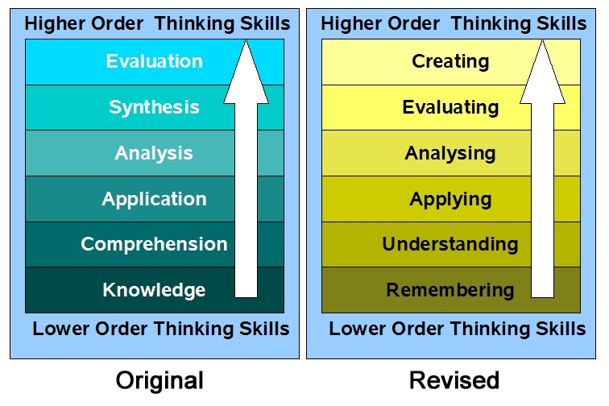

With that in tow, one can then select from the list of action verbs below to find one that is appropriate to the cognitive level of the student learning outcome6.

**How can I assess my learning outcomes other than using a pencil-and-paper examination?**

Evidence of student learning can take many forms. Again, when selecting your assessment tool, you must keep Bloom’s Taxonomy in mind so that you are addressing the cognitive level of thinking you wish to tease out from the student’s experience. It is always helpful to consult a taxonomy wheel such as the one illustrated below to help imagine what the final product will look like for the assessment7.

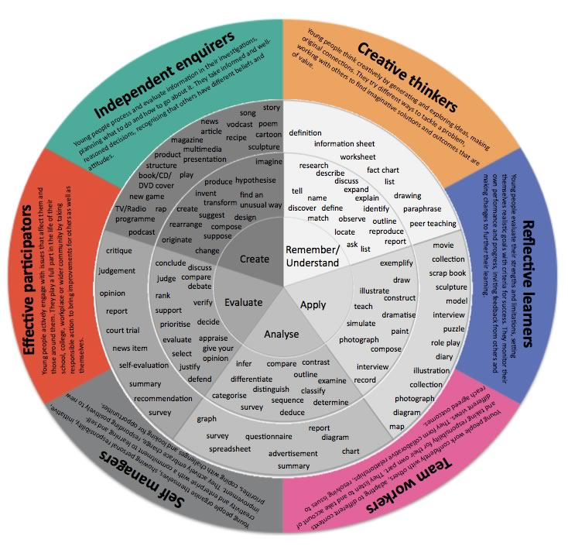

**I can determine the student has developed the competency, attitude, or habit of mind in the student learning outcome, but the outcome doesn’t lend itself well to being measured; how can I use this?**

Although we used the term “Measureable” as part of the SMART acronym, you should also see that “Verifiable” is an acceptable alternative. Not all products of assessment are measureable, and therefore need to be verified. This is particularly true with attitudes and habits of mind. You, as the instructor, are able to describe certain qualities of the product that indicate to you that the competency, attitude, or habit of mind from the student learning outcome has been attained.

**What are the forms assessment can take?**

There are three forms of assessment educators use in the process of teaching:

1.) **Diagnostic Assessment:** This form of assessment allows the instructor and/or the student to know the student’s knowledge, skills, attitudes, competencies, and/or habits of mind before any instruction takes place.

* Pre-tests
* Self-assessments
* Interviews

2.) **Formative Assessment:** This form of assessment allows the instructor and/or the student to know the acquired level of the student’s knowledge, skills, attitudes, competencies, and/or habits of mind during the instructional process, while learning is taking place. This form of assessment provides valuable feedback to the instructor as to the level of understanding for the both the student and the class as a whole.

* Teacher’s observations during in-class activities
* Homework exercises
* Reflective journals, portfolios
* Question and answer sessions
* Quizzes
* Conferences between the instructor and student (office hours)

3.) **Summative Assessment:** This form of assessment allows the instructor and/or the student to know the acquired level of the student’s knowledge, skills, attitudes, competencies, and/or habits of mind at the completion of the learning experience. This form of assessment provides feedback about the learning and the instructional process8.

* Unit examination
* End-of-course examination, Advanced Placement examination
* Final projects
* Final portfolios
* Performances, exhibitions
* Student evaluation of the course

**What are some examples of how I can provide evidence of student learning outcomes in my Professional Development Plan?**

Although this is not an exhaustive list, the following are suggested forms of evidence you can provide to the Professional Affairs Committee as evidence of student learning in your courses:

a.) Compare and contrast student performance on a pre-test and post-test related to a student learning outcome in your course. Provide data (both quantitative and qualitative) to support that the students have acquired the knowledge, skills, competencies, attitudes, and/or habits of mind related to the student learning outcome.

b.) Discuss your scores for an Advanced Placement course you teach. Note: It is important to provide data other than just how the students scored on a scale of 1-5. In this discussion, indicate how your students scored compared to the global means. This information can be obtained in the Teacher Planning Report prepared by the College Board.

c.) Indicate how your students did in certain competitions that placed your students up against other students locally, at the state level, and/or nationally related to a student learning outcome in your course.

d.) Take pictures of sculptures, maps, charts, murals, 3-dimensional projects, etc. that were submitted as assessments for a student learning outcome in your course, and describe how the pictures document that the student learning outcome has been met.

e.) Provide examples of movies, books, plays, diaries, podcasts, taped court trials, taped debates, cartoons, scrapbooks, etc. that were submitted as assessments for a student learning outcome in your course, and describe how they serve as examples of how the student learning outcome has been met.

f.) Provide examples or term papers, reports, surveys, research projects, etc. that were submitted as assessments for a student learning outcome in your course, and describe how they serve as examples of how the student learning outcome has been met.

g.) Provide examples of diagnostic, formative, and summative assessments (as they apply) and describe the cognitive development of the students in the process of meeting the student learning outcome.

1. 2012, National Institute for Learning Outcomes, <http://www.learningoutcomesassessment.org/TFComponentSLOS.htm>

2. 2010, Student Affairs, University of Oregon,

<http://sa-assessment.uoregon.edu/ResourcesandTraining/WritingStudentLearningOutcomes.aspx>

3. 2014, Faculty Professional Development Center, Kent State University,

<http://www2.kent.edu/fpdc/learning-and-teaching/learning-outcomes/index.cfm>

4. 2015, Center for Teaching and Learning, Indiana University – Purdue University Indianapolis,

<http://ctl.iupui.edu/Resources/Planning-the-Learning-Experience/Writing-Student-Learning-Outcomes>

5. University Teaching and Learning Center, The George Washington University,

<http://tlc.provost.gwu.edu/taxonomies-learning-outcomes>

6. Eberly Center for Teaching Excellence, Carnegie Mellon University,

<http://www.cmu.edu/teaching/index.html>

7. <http://www.mmiweb.org.uk/downloads/bloom2.html>

8. “Formative and Summative Assessment,” Arizona Western College

<https://www.azwestern.edu/learning_services/instruction/assessment/resources/downloads/formative%20and_summative_assessment.pdf>